
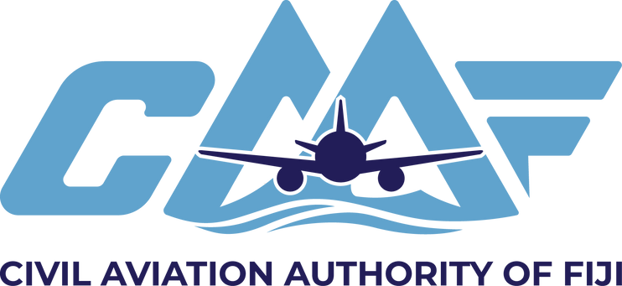

IMPORTANT

Before completing this form, its contents should be read carefully. Completed applications should be sent to the Civil Aviation Authority of Fiji, Private Mail Bag (NAP 0354), Nadi Airport, Fiji.

SECTION 1 | PERSONAL PARTICULARS OF APPLICANT (in BLOCK CAPITALS please)

Full Name (Surname first) Licence Number
Postal Address
Contact Details (Telephone, Fax and Email)

SECTION 2 | VERIFICATION DETAILS

- CAAF provides Licence Verification for individual licence holders by two methods:
  - Verification Letter - to applicant confirming licence details (letter sent to Postal Address detailed below)
  - Verification Report - emailed directly to overseas Authority
- Applicants must provide consent to release information directly to third party and confirmation of Identity

I hereby apply for the following:
 Verification Letter (Posted to Applicant); or
Verification Report (Emailed directly to overseas Authority)
For Verification Report - provide details of overseas Authority i.e. name of contact person, Position and Email address
Authority:
Name:
Position:
Email:

Fees
Official For Use Only
Calculation
Fee
Part:
Item:
Receipt
No.
Date:
Checked: Signature:
Date:

Applicable Fee

Confirmation of Identity
Certified copy of Passport or Certified copy of Birth Certificate

Send this completed and signed form to:

Civil Aviation Authority of Fiji Private Mail Bag NAP 0354 Nadi Airport
Republic of Fiji

Email: Licensing@caaf.org.fj Phone:(679) 8923155

SECTION 3 | DECLARATION AND CONSENT
I hereby certify that to the best of my knowledge and belief the statements made and the information supplied on this form is true and correct and that the enclosed copies of my personal documents are authentic and that information shown on them is true and correct. I hereby authorise such information to be disclosed by the CAAF to indicate person

Signature of Applicant: Date:

ALLOW 10 WORKING DAYS FROM DATE OF RECEIPT AS PER PROVISION OF CAAF SERVICE CHARTER

